**BCSCCS705R02- Parallel and Distributed Systems Lab**

**Lab Report**

**Experiment-1: Compute Dot Product of two vectors using CUDA Programming.**

* Dot Product is a reduction from vector to scalar. 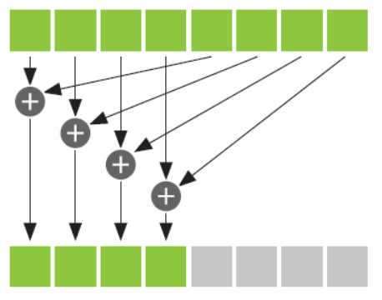
* **Example: $c=\overline{a}.\overline{b}$**

c= (a0, a1, a2, a3) ∙ (b0, b1, b2, b3)

c = a0 b0 + a1 b1 + a2 b2 + a3 b3

* Perform parallel, pair wise multiplications and serial addition. Store each thread result in a shared memory Using ***“___shared___”.***Synchronize the threads to maintain the order of execution of threads using ***“__syncthreads()”***before the serial addition. No thread executes instructions after ***“__syncthreads ()”*** until all threads have reached the ***“__syncthreads ()”.*** sum these pairwise products from a single thread. Launch ***add ()*** with N threads: **add<<< 1, N >>>()** Use threadIdx.x to access thread’s index. Use (threadIdx.x + blockIdx.x * blockDim.x) to index input/output. N/THREADS_PER_BLOCK blocks and THREADS_PER_BLOCK threads. gave us N threads total.

**Experiment-2:**  **Compute the product of two matrices.**

* Matrix multiplication: **P = A.B**
$$P=\left[\begin{matrix}a_{1,1} & a_{1,2} \\ a_{2,1} & a_{2,2}\end{matrix}\right]. \left[\begin{aligned}b_{1,1}b_{1,2} \\ b_{2,1}b_{2,2}\end{aligned}\right]$$

$$P=\left[\begin{matrix}a_{1,1}. b_{1,1}+a_{1,2}.b_{2,1} & a_{1,1}. b_{1,2}+a_{1,2}.b_{2,2} \\ a_{2,1}. b_{1,1}+a_{2,2}.b_{2,1} & a_{2,1}. b_{1,1}+a_{2,2}.b_{2,2}\end{matrix}\right]$$

* Map each data into thread using ***“row=blockIdx.x*blockDim.x+threadIdx.x” and “col=blockIdx.y*blockDim.y+threadIdx.y”.*** Matrix multiplication between two matrices ‘A’ and ‘B’ is done using the equation ***Px, y = 𝝨 Ax,,k*Bk,y, for k=0,1,2,....width.***  kernel that implements the above logic is defined as ***“ __global__ void matrixMultiplicationKernel(float* A, float* B, float* P, int width)”*** . Product is done in if condition to make sure that no extra threads don’t do any work. Launch ***“matrixMultiplication<<<blocksPerGrid,threadsPerBlock>>>(A, B, P, N);”***

**Experiment-3: Find the k-th largest element in an unsorted list of n elements initially distributed among p processors** .